Multi Vehicle GUI User Guider

1. 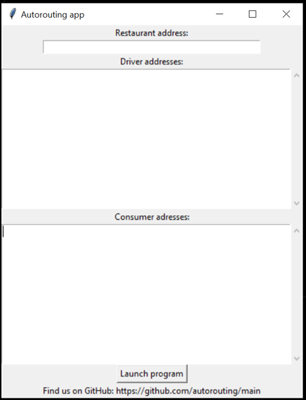Double click run_gui_multi.bat file to launch Autorouting App. The following form will be displayed.
2. 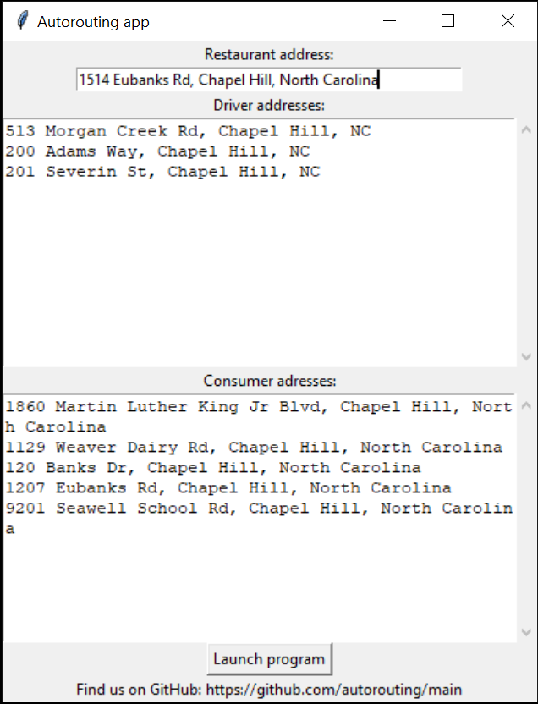Please fill the information corresponding to each input box’s label. If any box is left empty, a warning message will be displayed. When all the information is filled in, click Launch Program button to generate the routes for each driver.

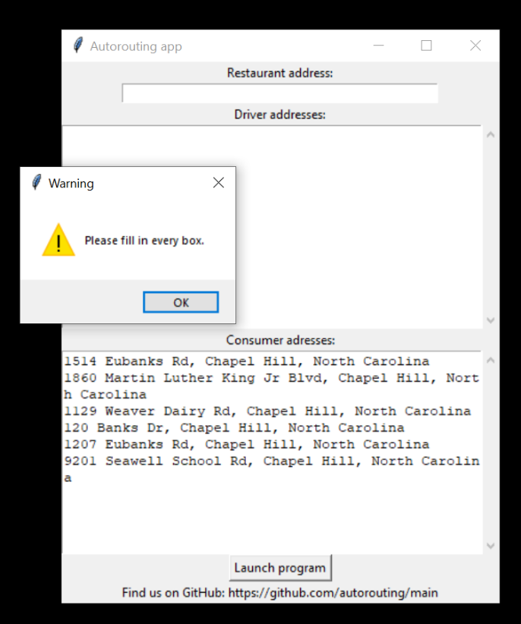

1. 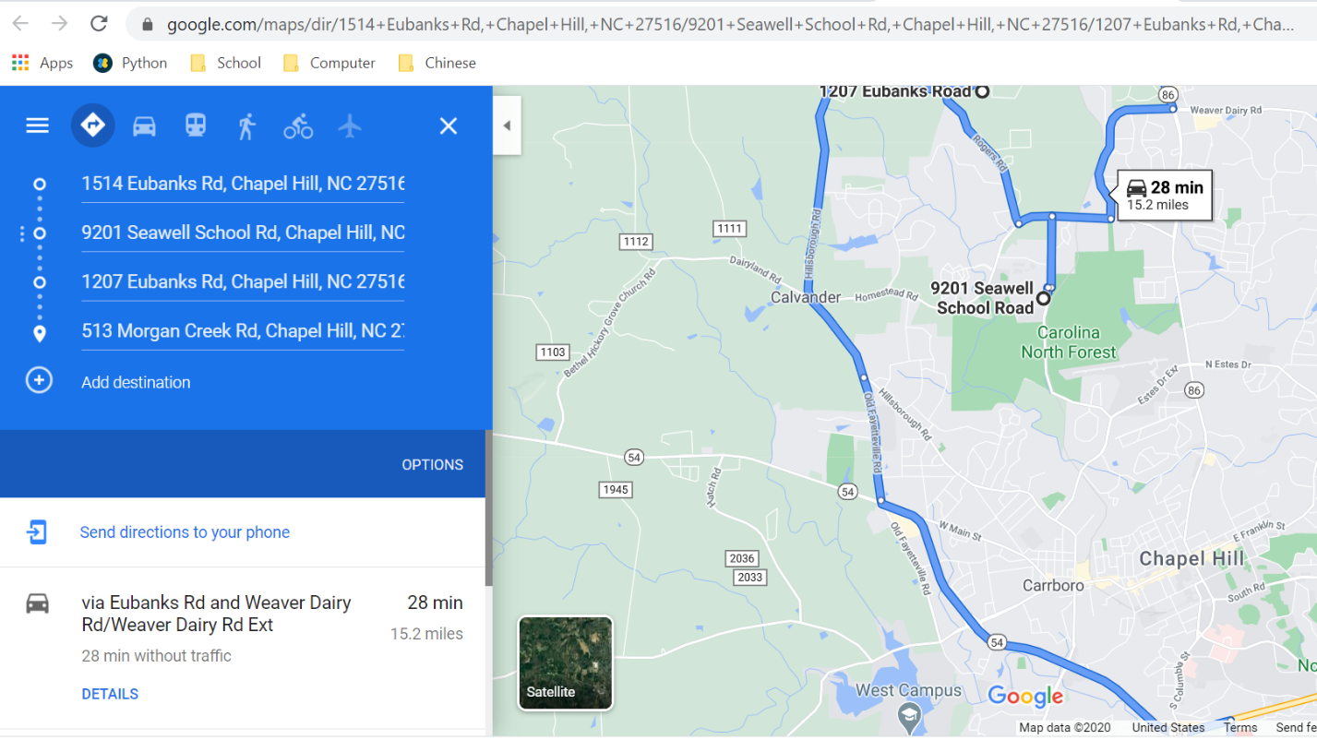A form with the routes for each driver will be displayed. Under each route, there is a button “Open Google Maps link in Browser” which takes you to a Google Maps link with the route.

